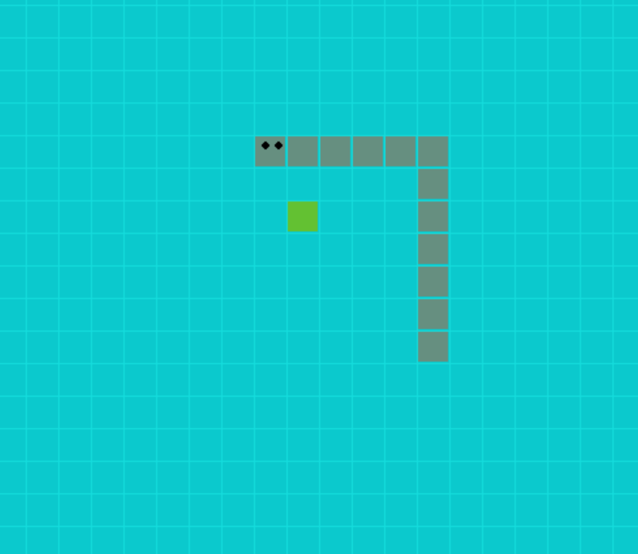
Snake game
A PYTHON CREATION
Enrique Marcello Nahcotta Haugen Goodell | 23/5/23 | Information Technology

Contents
Contents 1
Innhold 1
A simple introduction 3
Network diagram 5
Project Plan 6
General data base structure 7
Data Base Screenshot 8
Link YouTube Tutorial 8
IT Apprentice Tutorial 9
Technical Documentation 10
Mapping of rules and laws 11
Risk Analysis and Action Plan 12
Link to GitHub 12
Personal Evaluation 13
Sources 14

A simple introduction

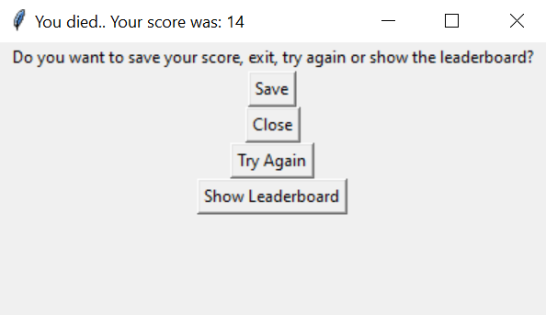
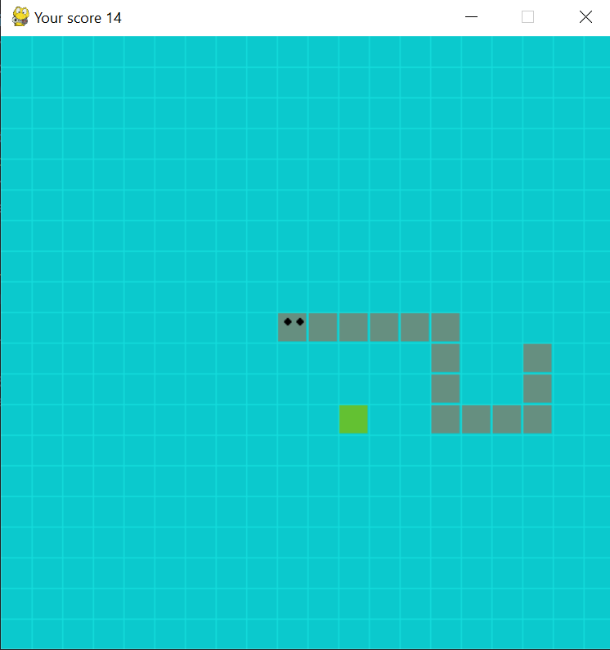
Throughout the time of planning, deciding, and creating my project, my conclusion was to design and produce a game. This game was going to be the framework which was to then become the entirety of my project. This project is based off a basic game that I coded in the language Python. The game I decided to create is Snake. Snake is a classic game that requires you to go around a predetermined field and gather “food” to increase your size. This then creates your score. Your score is then displayed and shown at the top left of the screen. The goal is then to get the highest score before you die or lose. Now there are different versions of this game, but in my solution the only way you can lose is by hitting yourself. There are no barriers, for if you were to reach one side of the screen, you would merely appear on the other side. If you were unlucky and died, you are then greeted with an abundance of options.
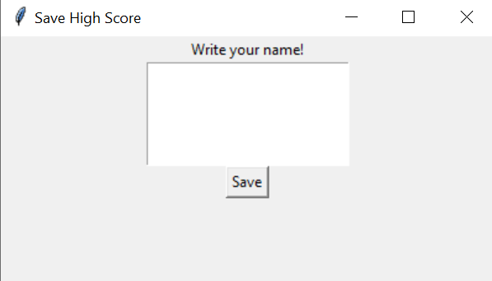
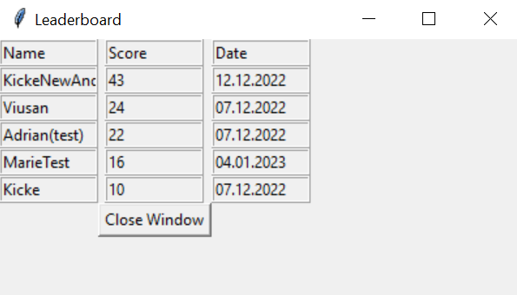
One of those options is to save your score and if you choose to save, then the data is saved to a database on an external physical server that I have set up. Once you click the save button, you will be approached with the menu you see to the right. You will then be asked to put in a name of your choosing and then click save. Below you see the leaderboard. After you pressed save, you will be brought back to the main menu. There you can choose to display the leaderboard. Here you can clearly see who the best is. ;) If you choose either, you have the option to try playing the game again or closing it entirely.

As well as this I also have my database. Which is where the scores are uploaded too. They do this by establishing a physical connection by using of switch between my server which runs the phpMyAdmin database and the client machine which hosts the game through. They are then set up on their own private network which allows communication between the server and client. Finally, I have my FAQ-page which runs on a separate webserver. This webserver is also on its own physical machine that establishes connection with the database server through the same network as the rest of my equipment. They all then co-exist and ensure that the user has a fine experience of playing the game, as well as giving admins and other personal access to the webserver and database server if need be.

Network diagram

Project Plan

General data base structure

Data Base Screenshot
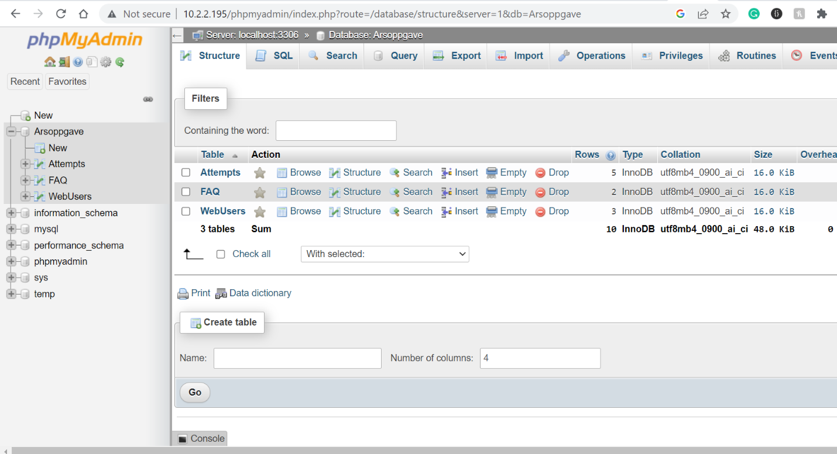

Link YouTube Tutorial
https://youtu.be/mVL4WXId3os

IT Apprentice Tutorial

Technical Documentation

Mapping of rules and laws

Risk Analysis and Action Plan

Link to GitHub
https://github.com/KickeGoodell/Arsoppgave.git

Personal Evaluation
Throughout this project I have run into an abundance of issues and challenges that I had to face and solve mostly on my own. These have been challenges that I believed were easy to solve, but usually in the tech world, when you stumble upon one challenge, you’re merely scraping the surface. My main issues were connecting to the database. When I finished coding my game and got it up and running, I had to have a way to save my score right? I knew that I had to run a code that would connect to the database, that much was certain. I figured out the code and how to connect to the database, but when I tried to upload the data, it simply didn’t work. I struggled and struggled to figure out how I connected to the database, because I believed that my code was wrong. As a result, I realized that it wasn’t the game at all or the code, but it was the Python coding language. Apparently, without me knowing, I needed to install a plugin on python that made it possible to connect to mysql databases. This is something that I didn’t know. So, after weeks of troubleshooting my code, my database static IP-address and my client’s network connection, the simple solution was to install the plug in for python.
Another issues I ran into which was worth mentioning was my webserver. I had to set up a webserver to host my FAQ page, because I felt for security reasons, it was best to have the website running on a separate server. Unfortunately to move over files wasn’t as easy as I anticipated. After I finished setting up the webserver, I attempted to move over the files necessary to run the website. I believed that simply moving the files to a flash drive and then placing them in the webserver was the simplest form of transferring. Well, after doing so I didn’t take into consideration the thought of a Flash drive trying to understand css and html files. The html files it could read, but it translated the css files into complete binary, which lead to me having issues running the css on my website.
I later found a method to safely copy files from a machine to my webserver using a scp command. And that worked, but then I wanted to try and simplify the base website directory and avoid having a lot of websites there. I did this by linking the files to that website directory from somewhere else in the webserver. But then I ran into issues with permissions and allowing users to see the website. I couldn’t find a solution to the permission issues, but I knew that there were some issues with s linking (that was the command I used to link the files to that website directory) And after figuring out that, I simply safely copied the files directly into the website directory.
The thing I’ve mainly learned from this project is the communication between code, server and machines. I already knew a bit about coding, how a server is used, and how machines communicate with each other. But to find a way to translate code into data that a server can understand and then on top of that, have the code and server run on to separate machines and create a line of communication between all those factors was beyond me. It was inspiring and fun to learn how to establish communication between machines and have the machines all do separate things. I have also learned more about documentation and how important it is to bring in laws and regulations to ensure that your project doesn’t create conflict.
I had high ambitions and hopes when I started this project. I mainly wanted a much larger game then what I ended up with. I also wanted to find a way to implement a potential app into my project. But throughout going through this project, its important to remember that time matters and that things take time. I believe after the compromises I made; I was happy with the result. A way to play a game, save your score, see other players score and then ask questions on a FAQ page if needed a great thing that I believe I pulled off well within my project. If there was anything I would do differently if I was starting over, was to build up one piece at a time and realize just how much time I really have, be patient and don’t rush things. I am happy with my result. I feel this project is a great foundation to a potential much larger project in the future!

Sources
https://rufus.ie/en/
https://ubuntu.com/download/server
https://www.digitalocean.com/community/tutorials/how-to-install-linux-apache-mysql-php-lamp-stack-on-ubuntu-20-04
https://www.digitalocean.com/community/tutorials/how-to-install-mysql-on-ubuntu-20-04?locale=en-us#introduction
https://www.digitalocean.com/community/tutorials/how-to-install-mysql-on-ubuntu-20-04?locale=en-us#introduction
https://stackoverflow.com/
https://www.w3schools.com/

